Lila Risnes
Mobile 07592 943 478  Email lilarisnes@gmail.com  Spotlight 2378-4537-0829  Height 5’ 4,5” (164 cm)  Eyes Green  Hair Dark blonde  Training  - BA (Hons) Actor Musicianship  Rose Bruford College (2017-2020) | 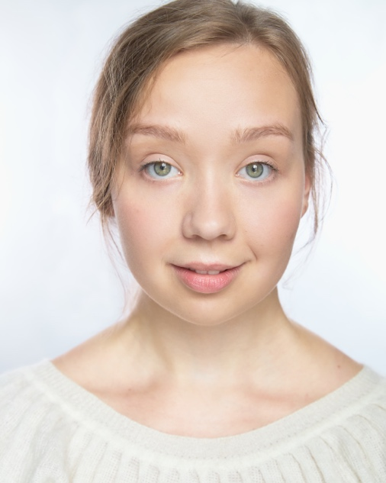
Theatre

Production |  | Role | Director |  | Venue/Company
From Morning to Midnight  King Lear | Daughter/Harlequin  Cordelia |  |  | Luke Kernaghan  Francesca Murray-Fuentes |  | Rose Bruford College  Rose Bruford College
Labels and Layers  Who is Afraid of Darkness?  Dame Decibel  The Theban Motherf**ker | Barbara  Else  Daughter  The Sphinx |  |  | Saya Zahawi  Annika Kordes  Lila Risnes  Alexandra Spencer-Jones |  | Liars Lovers Loser’s Luck  Rose Bruford College  Rose Bruford College  Rose Bruford College
Seven Doors  The Maids | The Void  Claire |  |  | Julian Jones  Alison Mackinnon |  | Rose Bruford College  Rose Bruford College
Three Sisters  Nøtteknekkeren (The Nutcracker) | Olga  Servant/Rat |  |  | Jeremy Harrison  Arvid Ones |  | Rose Bruford College  Trøndelag Teater
Ingen Nordmenn Savnet | Lara, Lotto Ball nr 1 |  |  | Catrine Telle |  | Trøndelag Teater

TV/Film

Production | Role | Director | Venue/Company
Reconstructing Utøya | Various roles | Carl Javér | Vilda Bomben Film AB et.al.

Accents/Dialects: General American, Norwegian*, Nordic, RP, Swedish*

Languages: Norwegian*, English*, Basic Spanish

Skills (* = highly skilled): Knitting*, Playwriting*, Cycling, Clown, Crochet, Devising, Meisner Technique, Music Teacher, Sewing, Stage Combat, Swimming, Story Telling, Tour Guide, Translating, Workshop Leader, Writing.

Musical Skills (* = highly skilled): Soprano* (D3 – D6, belt to D5). Piano*, Accordion, Arranging, Flute, Guitar, Classical singing*, Harmony Singing, Improvisation, Musical Directing, Musical Theatre Singing, Norwegian Folk Singing, Sight Reading, Song Writing.

